Type the paper title (17 pt)
First Author^{*1}, Second Author², Third Author³
¹Affiliation of first author
²Affiliation of second author
³Affiliation of third author

E-mail: corresponding email of first author¹, email of second author ², email of third author ³

Abstract. All articles must contain an abstract. The abstract text should be formatted using 10-point Times or Times New Roman and indented 25 mm from the left margin. Leave 10 mm space after the abstract before you begin the main text of your article, starting on the same page as the abstract. The abstract should give readers concise information about the content of the article and indicate the main results obtained and conclusions drawn. The abstract is not part of the text and should be complete in itself; no table numbers, figure numbers, references or displayed mathematical expressions should be included. It should be suitable for direct inclusion in abstracting services and should not normally exceed 200 words in a single paragraph. Since contemporary information-retrieval systems rely heavily on the content of titles and abstracts to identify relevant articles in literature searches, great care should be taken in constructing both.
Keywords: max 5 keywords from paper, separate using semicolon.

- Introduction
This template refers to J. Phys.: Conf. Ser. with some modifications. The page size should be A4. The article should be 10-12 pages. The page should not contain page numbers, running heads or foot lines.

- Title, author and affiliation format
Please follow the instructions below so that all incoming scripts will have the same style. The paragraph aligns with the title section so it does not need to be indented.
  - Title Format
The title is 17 points in Times New Roman Bold font, left aligned, not justified, not indented. Leave 28 mm space above the title and 10 mm after the title.
  - Author Format
The author list must be indented 25mm so that it is aligned with the abstract. The names are written in initials or abbreviations for the first and middle name, then followed with the last name. Separate each author with a comma. The initials or abbreviations do not end with a period, for example A J Smith not A. J. Smith.
  - Affiliation Format
Please ensure that affiliation is written as completely as possible including the country. Affiliations are written with 25mm indention and align with the abstract. If the authors come from different affiliations, superscript numbering must be used after each last name to refer the author with the affiliation. Superscript numbering should not be entered with a footnote because it will enter references in the wrong place (at the bottom of the page or at the end of the document). Make sure that each superscript numbering connects the name of the author and affiliation starting from 1. Do not add footnotes until all author names are linked to their affiliation.
For example:
J Mucklow¹, J E Thomas² and A J Cox³
superscript numbering 1, 2 and 3 is used to link the name to its affiliation.

- Writing format
The writing should follow the following format:
- 11-point Times New Roman.
- The article must be set in single line spacing.
- The paragraph must be justified.
- The first paragraph after the section or subsection heading may not be indented and the next paragraph must be indented 5mm.

- Sections, subsections and subsubsections
The use of sections to divide the writing from the manuscript is optional. IJIS leaves the writing division to the authors. When the authors divide their writing into sections, they should follow the format shown in table 2.
  - Style and spacing

Table 2. Formatting section, subsection and subsubsection.
 | Font | Spacing
Section | 11-point Times bold | 1-line space before the new section  Space after heading section is not necessary
Subsection | 11-point Times Italic | 1-line space before new subsection  Space after heading section is not necessary
Subsubsection | 11-point Times Italic | Subsubsection should end with a full stop (do not need to click enter), and is followed with the text
  - Numbering
Sections must be numbered with a period following the numbers and separated by a single space:
- sections are numbered with 1, 2, 3, and so on.
- subsections are numbered with 2.1, 2.2, 2.3, so on.
- subsubsections are numbered with 2.3.1, 2.3.2, so on.

- Footnotes
The use of footnote is not advisable. Footnotes are only used for short notes that are not enough to be placed in the text.

- Figures
Each image must have a short caption to explain the picture.
  - Space considerations
The author should try to make a consideration in using spaces in the page, for example:
- Avoid the use of excessive white spaces around the graphs/figures
- Design the illustration that creates appropriate space use. Avoid the use of excessive white spaces around the graphs/figures
  - Texts in the figures
Make sure that the size of the text in the image (separate from subscript / superscript) is approximately the same size as the size of the text in the main text (11pt).
  - Line Thickness
In general, avoid thin lines because they result poor quality of printing. The diagram or image will lose vital information when downloaded or printed by other researchers. Make sure the line is thicker than 0.25pt. To add, some illustrations might reduce the thickness of the line when the chart is imported and reduced in size (scaled down) on Ms. Word.
  - Colored Illustration
The use the colorful illustrations is for the online version of IJIS while the printed version is in black and white.
  - Figure positioning
Individual image must be centered and two images must be positioned side by side. Place the image as close as possible to the situation/description in the text. If there are several images, place them before the situation. Images may not be displayed in or on the reference list.
  - Figure Caption Numbering
Captions must be placed under the image and separated with a distance of 6 pt. To save space, it is acceptable to place the caption next to the image. Images must be numbered consecutively. ‘Image 1’, ‘Figure 2’, etc. and must be referenced in the text as ‘image 1’, ‘image 2’, etc. not with ‘fig. 1’, ‘fig. 2’, ...
For captions that are not placed next to the image, the caption must be adjusted according to the width of the image in the center, or for shorter images with longer captions, the caption must be beside the image adjusting the width of the image.
    - The following examples show how to format the numbering of several kinds of figures/images. Note: the dotted lines are only for guidance (Do not include the dotted lines when making the article).

Figure 3. Figure with short caption (centered caption)
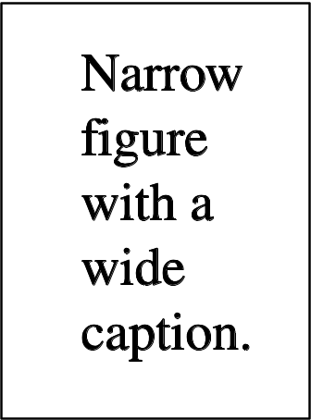 | Figure 4. This is the figure with longer caption. For efficiency, the caption can be placed beside the figure and place the caption in a table consisting of one row and two columns


Figure 5. In this case, justify the caption so it has the same width as the figure
Figure 6. The two figures are positioned side to side to save the space |  | Figure 7. The two figures are positioned side to side to save the space.
  - Figures with sections
If an image has parts, they must be labeled with (a), (b), (c) and so on. The captions of these parts must not be separated.

- Table
The table format uses the general rule. For large tables, the font size can be scaled down so the tables fit to the page or width of the text.
  - Table Position
Tables must be centered unless they occupy the entire width of the text.
  - Tables with sections
If a table is divided into sections, it should be labeled with (a), (b), (c) and so on and must contain only one caption for one table.
  - Table caption/numbering
Tables must be numbered sequentially and referenced in the text with their numbers (table 1, not tab. 1, etc). The caption must be placed on the table. For short tables with long caption (see example below), the caption must be the same width as the table width.
  - Rules in table formatting
The table only has horizontal lines without vertical lines. In general, only three lines are used namely the table's top line, the table's bottom line, and the line that separates the contents of the table from the column headings. Line thickness of the table is 0.5 pt.
  - Example

Table 3.
A simple table. Put the caption on the table. In this case, the caption is longer than the table. Justify the text and then provide 6 pt of space between the caption and the top of the table.
Distance (m) | Velocity (ms^{–1})
100 | 23.56
150 | 34.64
200 | 23.76
250 | 27.9

    - Complex table. Below is a more complex table with a shorter caption. Position the caption in the middle. If it is difficult to fit the table with the page, use a smaller font.

Table 4. A slightly more complex table with a narrow caption.
 | Wake Chi Sqr. (N=15, df=1) | p | Stage 1 Chi Sqr. (N=15, df=1) | p | Stage 2 Chi Sqr. (N=15, df=1) | p
F3 | 1.143 | 0.285 | 0.286 | 0.593 | 0.286 | 0.593
Fz | 1.143 | 0.285 | 0.067 | 0.796 | 0.067 | 0.796
C4 | 2.571 | 0.109 | 0.600 | 0.439 | 1.667 | 0.197

Table 5. A slightly more complex table with a caption that is the same width as the table. Simply place the caption inside a row at the top of the table and merge (combine) the cells together so that you have a single table cell the width of the table. Justify the caption.
 | Wake Chi Sqr. (N=15, df=1) | p | Stage 1 Chi Sqr. (N=15, df=1) | p | Stage 2 Chi Sqr. (N=15, df=1) | p
F3 | 1.143 | 0.285 | 0.286 | 0.593 | 0.286 | 0.593
Fz | 1.143 | 0.285 | 0.067 | 0.796 | 0.067 | 0.796
Cz | 1.143 | 0.285 | 0.077 | 0.782 | 0.286 | 0.593
  - Notes
If the table has footnotes, the footnotes must be formatted using alphabetic superscript like ª, ^{b}, ^{c} dan so on. Notes in the table caption must be registered first. Records must be placed at the bottom of the table. One method that can be applied is to create a blank row at the bottom of the table to make a note. Then merge the cells to get a single cell according to the width of the table. Table records must be 10 pt Times New Roman. Each note must be separated by a new line.
Table 6. A table with headings spanning two columns and containing notesª.
Nucleus | Thickness  (mg cm^{–2}) | Composition | Separation energies
Nucleus | Thickness  (mg cm^{–2}) | Composition | , n (MeV) | , 2n (MeV)
¹⁸¹Ta | 19.3±0.1^{b} | Natural | 7.6 | 14.2
²⁰⁸Pb | 3.8±0.8^{c} | 99% enriched | 7.4 | 14.1
²⁰⁹Bi | 2.6±0.01^{c} | Natural | 7.5 | 14.4
ªNotes are referenced using alpha superscripts.
^{b}Self-supporting.
^{c}Deposited over Al backing.

- Equation and Math
  - Fonts in Equation Editor (or MathType)
Make sure the Equation Editor is adjusted to the same font size as your document.
  - Points of style
    - Vectors. Bold italic characters is set but the author can use standard notation. The following are examples of acceptable formats:

‘the vector cross product of a and b is given by 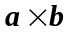…’, or
‘the vector cross product of a and b is given by 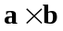…’, or
‘the vector cross product of and is given by 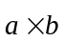…’.
8.2.2 The solidus (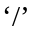).A two-line solidus should be avoided where possible; For examples:
- 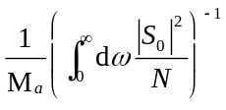instead of 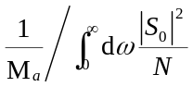
- 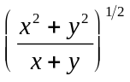 instead of 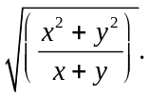
8.2.3 Roman and italic in mathematics. Variables should be in italic; however, there are some cases where it is better to use a Roman font:
- Use a Roman d for a differential d, for example, 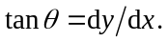
- Use a Roman e for an exponential e; for example, 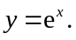
- Use a Roman i for the square root of –1; e.g., 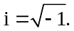
- Certain other common mathematical functions, such as cos, sin, det and ker, should appear in Roman type.
- Subscripts and superscripts should be in Roman type if they are labels rather than variables or characters that take values. For example, in the following equation
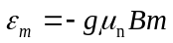
m, the z components of the nuclear spin, is italic because they can have different values whereas n is Roman because it is a label meaning nuclear.
  - Alignment of mathematics
The preferred style for displayed mathematics in IJIS is to center equations; however, long equations that do not fit on one line, or need to be continued on subsequent lines, should start flush left. Any continuation lines in such equations should be indented by 25 mm.
Equations should be split at mathematically sound points, often immediately before =, + or – signs or between terms multiplied together. The connecting signs are not repeated and appear only at the beginning of the turned-over line. A multiplication sign should be added to the start of turned-over lines where the break is between two multiplied terms.
Examples of short equations:
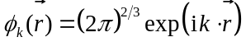 (1)
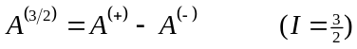 (2)
However, if equations do not fit on one line, the equation can be written as follow:

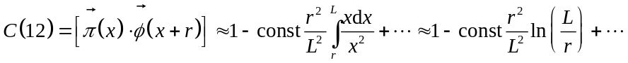 (6)
Large display equations: If an equation occupies the width of a line, place it flush left against the margin to allow room for the equation number.
(7)
  - Miscellaneous points
- Exponential expressions, especially those containing subscripts or superscripts, are clearer if the notation  is used, except for simple examples. For instance, 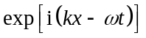and 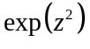 are preferred to 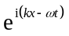and 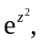 but 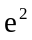is acceptable. Similarly the square root sign 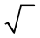 should only be used with relatively simple expressions, e.g.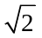 and 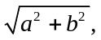 but in other cases the power 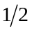should be used.
- It is important to distinguish between 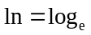and 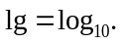
- Braces, brackets and parentheses should be used in the following order: {[()]}. The same ordering of brackets should be used within each size. However, this ordering can be ignored if the brackets have a special meaning (e.g. if they denote an average or a function).
- Decimal fractions should always be preceded by a zero. For example, 0.123 not .123 (note, do not use commas, use the decimal point).
- Equations that are referred in the text should be numbered with the number on the right-hand side.

  - Mathematical Equation Numbering
Mathematical equations can be numbered sequentially like ((1), (2), (3),…) or numbered by section (i.e., (1.1), (1.2), (2.1) ,…) according to the author's preferences. When referring to an equation in the text, always put the formula number in parentheses. Example: ‘as in the equation (2)’ or ‘
as in the equation (2.1)’.

- Acknowledgement
Gratitude for assistance, encouragement, special work by technical staff, and financial support from an organization must be mentioned in the Acknowledgments section.

- References
IJIS uses the IEEE reference style. It is recommended to make references with Mendeley's tools [1] with minimal 15 references consisting of 80% journal articles. It is preferable to use recent references or no longer than 10 years, except the references are considered to be very important. The references are numbered according to the order of their appearance in the text [2]. In the text, the reference should be written as [3], do not use “Ref[3]” or “reference[3]” except for the beginning of the text such as “Reference [1] states that...”
Et. al is used when the article is composed by more than 6 authors. The unpublished paper, even when the paper has been submitted, should be cited as “unpublished” [4]. The paper that has been accepted in a journal should be cited with “in press” [5].
- G. Eason, B. Noble, and I. N. Sneddon, “On certain integrals of Lipschitz-Hankel type involving products of Bessel functions,” Phil. Trans. Roy. Soc. London, vol. A247, pp. 529–551, April 1955. (references)
- J. Clerk Maxwell, A Treatise on Electricity and Magnetism, 3rd ed., vol. 2. Oxford: Clarendon, 1892, pp.68–73.
- I. S. Jacobs and C. P. Bean, “Fine particles, thin films and exchange anisotropy,” in Magnetism, vol. III, G. T. Rado and H. Suhl, Eds. New York: Academic, 1963, pp. 271–350.
- K. Elissa, “Title of paper if known,” unpublished.
- R. Nicole, “Title of paper with only first word capitalized,” J. Name Stand. Abbrev., in press.
- Y. Yorozu, M. Hirano, K. Oka, and Y. Tagawa, “Electron spectroscopy studies on magneto-optical media and plastic substrate interface,” IEEE Transl. J. Magn. Japan, vol. 2, pp. 740–741, August 1987 [Digests 9th Annual Conf. Magnetics Japan, p. 301, 1982].
- M. Young, The Technical Writer’s Handbook. Mill Valley, CA: University Science, 1989.

